**Frontend Assignment**

**Problem Statement:**

Develop a simple web app to search music and create playlist, similar to Spotify

**Description:**

You need to create a small web app to let the user search for music and create playlist and add music to favourite. You can directly use the API mentioned below, no need to rest API. This app will also require the user for authentication by Keycloak

**Sample API:**

You can use any free Api available online or could use from our recommendation <https://rapidapi.com/apidojo/api/shazam/>

**Minimum Requirements:**

1. There should be a sidebar containing Home, Search, favourites, and playlists
   1. **Home**: Show the list of user playlist and user favourites music
   2. **Search**: Type keyword to search music & Auto search complete
   3. **Favourites**: Display list of music “⭐” starred by user
   4. **Playlists**: list of music playlist created by user, and also a button to create more playlist.
2. User need to login and authenticate before going to the home screen.
3. Authentication will done by keycloak.

**Must have:**

1. Single Page Application
2. Clean & fluidic layout – use bootstrap (5.0) only
3. Error-free, **Readable, Simple & Clean code**
4. Let me stress the previous point - **Readable, Simple & Clean code**
5. Minimum third-party dependencies
6. Code must be written in **TypeScript only**, no JS code will be accepted
7. **Technology Stack:** ReactJS, docker

**Bonus Points:**

1. User could retain the saved list even after closing the browser
2. Hover effects on individual items
3. Use of redux for state management

**Quick Hint:**

You can use local storage to save the user preferences.

**Few links for reference:**

1. Keycloak - <https://www.keycloak.org/> & <https://www.keycloak.org/getting-started/getting-started-docker>

**Sample UI:**

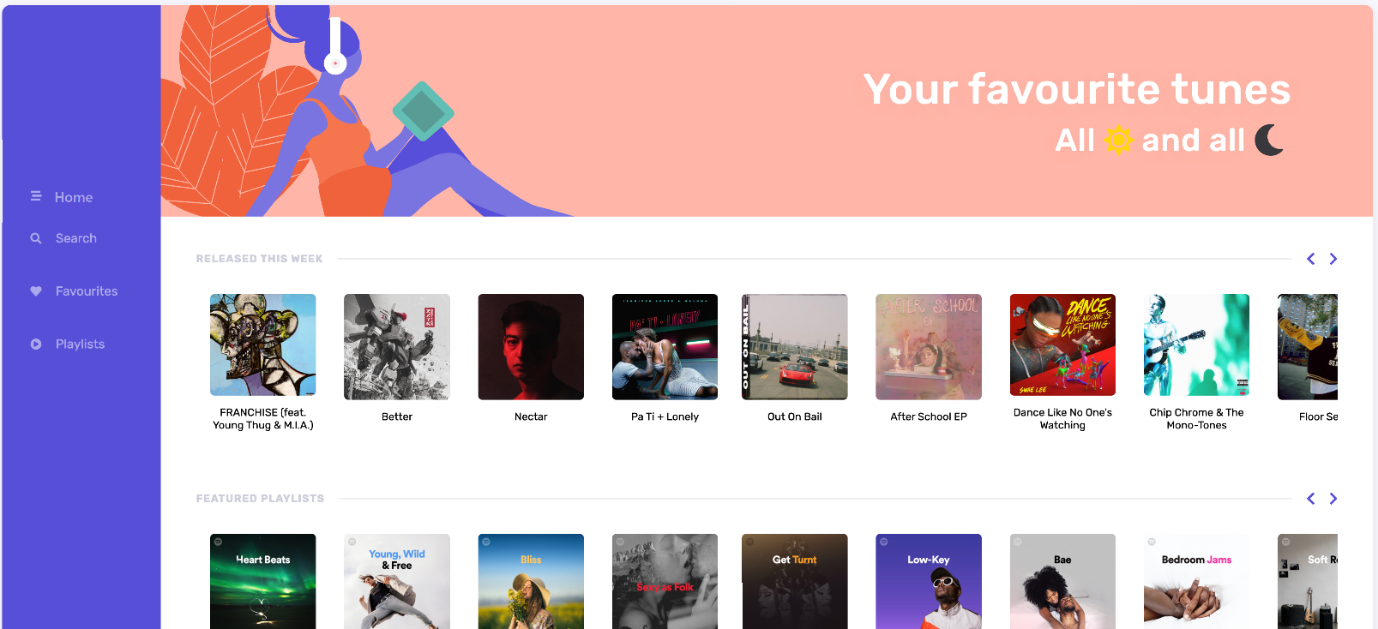

**Note:**

1. **PLEASE NOTE THAT, WE HAVE A ZERO TOLERANCE POLICY FOR PLAGIARISM. IF YOU PLAGIARIZE THE TEST, YOU WILL BE CAUGHT AND IMMEDIATELY TERMINATED.**
2. **Please do not submit the code if code is not up to a standard.**
3. **Please do not submit the assignment if UI doesn’t look clean and beautiful like image above.**
4. **Please do not send LinkedIn Request to Connect!**
5. **PLEASE MAKE SURE YOU SUBMIT EVERYTHING VIA A GITHUB LINK AND PLS UPLOAD ALL ASSETS AND FILES. PLEASE MAKE SURE YOU UPLOAD THE SCREENSHOT OF THE FINAL APPLICATION YOU BUILD.**